

**THE UNIVERSITY OF BRITISH COLUMBIA**

**COSC 360 Web Programming**

**Client Side Experience**

**RedGram**

February 27, 2023

Syed Faraz (16245342)

Tsogt(95050811)

## Site map:

Bellow you can see a site map featuring the log in page from which the user can access only one page which is the main page of the site. After the main Page all three main pages can be accessed, the profile, notifications, and community. In each 3 main page there are interconnected pages that can be accessed. The rest 4 pages at the very bottom aren't actual pages but pop up menus.

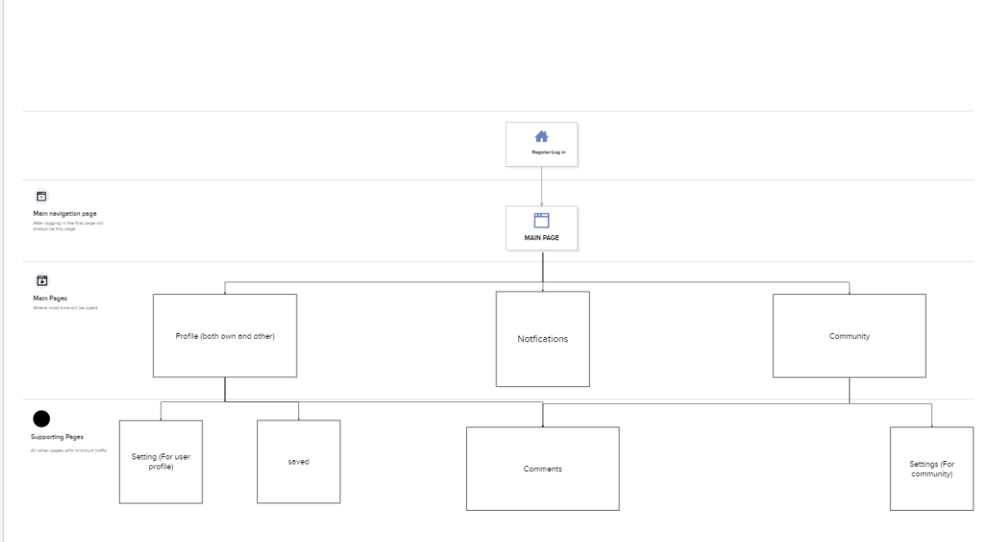

**Static design and styles of pages: All static elements have been left and dynamic elements have been removed**

Below is the Register/Login page of the website which will always be the first page to be accessed

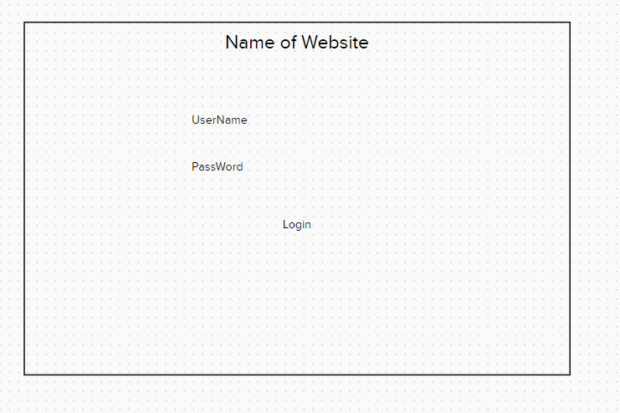

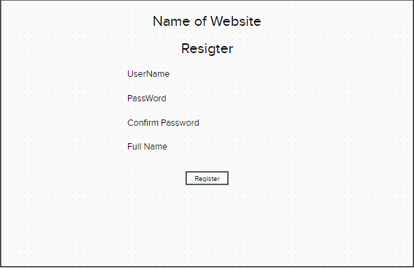

After the login/register page the main page will be the first one accessed from which, as can be seen through the buttons available, all other pages will be accessible.

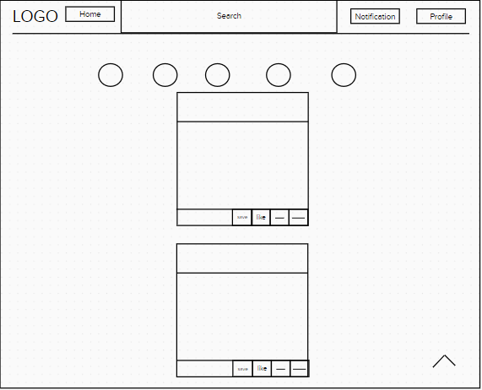

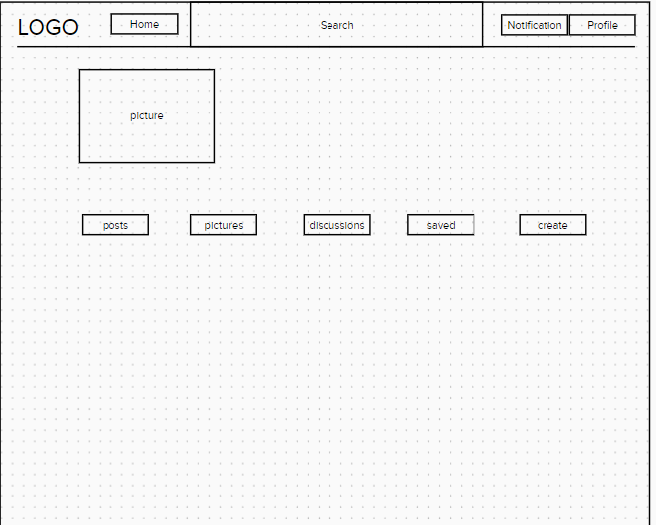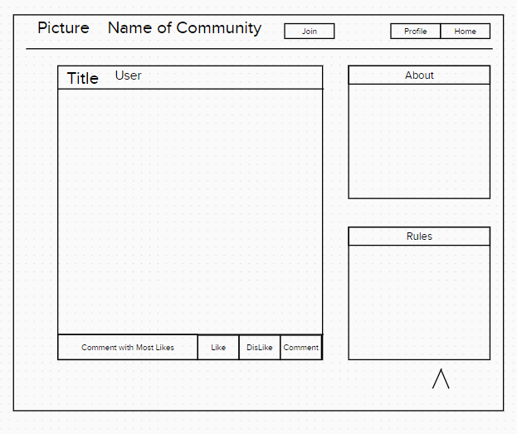



## Examples of each page type & Layout:

## Logic Process

People will be able to Register for an account that will grant them access to certain

Functions:

* Make their accounts public or private
* Create/join communities
* Comment on posts
* Create posts on their profile and/or communities they are a part of
* Receive notifications on their posts/comments/community
* Tags, replies, deletion
* Add/remove friends and/or drop out of communities
* Like/dislike posts and communities
* Create short videos and put them in an album that will be deleted within 24 hours
* of the post
* Registered users can also view who and how many people have viewed their
* videos/communities/posts/ profiles.
* Unregistered users will be able to view posts and communities that are public
* Will not be able to add/dislike posts and communities
* Will not be given a personalized feed as they can’t follow any person or community but rather can search for specific ones

## Client Side Validation

Here is a prototype of what the site will entail regarding the client-side validation:

Every time a user makes an account, the user will be asked to fill out a form that requires specific answers at specific spots. If the user misses anything, an error message is shown as an output highlighting where the user may have made a mistake.

Moreover, the website stores the data such that no other user is able to replicate the values. For example, once a username has been selected no other user may gain access to that username. This applies to the email address too. Once an account linked to an email account is created, another account will not be able to use the same email id. Furthermore, the syntax of the email id must be correct otherwise it is deemed invalid.

